COMPANY PROFILE


PROPRIETOR : MR. PHUSE KHAN
Mob. No.: 9820 216 437 / 9619 057 606
Email ID: spconst44@gmail.com

Office Address: Bldg No. 24/B/4, Sultanabad Ashish, Behram Baug Road, Jogeshwari (W),
Mumbai 400102

C O N T E N T S

- Introduction
- Company Resume
- List of Technical Staff
- Labour Strength
- List of Tools Machinery / Equipment
- List of Work Completed & Work in Progress
- Picture of Various Work

COMPANY INTRODUCTION

S.P. CONSTRUCTION is committed to providing high quality and professional services to the building repairing, structure strengthening, painting & interior works throughout the Mumbai & surrounding region. We continually endeavour to improve project outcomes through adherence to our certified quality, work health and safety and environmental systems

BACKGROUND

The company has been operating in the Mumbai and surrounding region since 1990. Originally focussing on structural repair and building renovation

S.P. CONSTRUCTION can provide a complete range of civil contracting with extensive in civil construction, repairs, painting, road construction, plumbing and allied works.

COMPANY RESUME

S.P CONSTRUCTION
BUILDING REPAIRS, COATINGS, PAINTING & INTERIOR WORKS

C O M P A N Y R E S U M E

: S.P. CONSTRUCTION

NATURE OF BUSINESS : CIVIL ENGINEERS & CONTRACTORS

PROPRIETOR : MR. PHUSE KHAN

TYPES OF SET UP : CIVIL ENGINEERS & CONTRACTORS

OFFICE ADDRESS : BLDG NO.24/B/4, SULTANABAD ASHISH, BEHRAM BAUG ROAD, JOGESHWARI (W), MUMBAI 400102

MOBILE NO. : 9820216437 / 9619057606

EMAIL ID : spconst44@gmail.com

ESTABLISHMENT : 25/02/1990

NAME OF BANK : BANK OF BARODA

EXPERIENCE : 30 YEARS

LIST OF TECHNICAL STAFF

NAME | POST
PHUSE KHAN | PROPRIETOR
SALIM KHAN | PROJECT MANAGER
AYUB KHAN | CIVIL ENGINEERS
SHAFIQ SAYED | SITE ENGINEER
GANPAT RAM | ACCOUNTANT
KADIR KHAN | SITE SUPERVISOR

LIST OF TOOLS & MACHINERY

SR. NO. | NAME OF EQUIPMENT | NOS.
1 | BAMBOO SCAFFOLDING | 10 Nos.
2 | STEEL SCAFFOLDING | HIRE
3 | PROPS | More Than  50 Nos.
4 | CONCRETE BIG MIXER | HIRE
5 | AIR COMPRESSOR | 3 Nos.
6 | GUNNITTING MACHINE | 1 Nos.
7 | GROUTING MACHINE | 1 Nos.
8 | WELDING MACHINE | 1 Nos.
9 | DRILL MACHINE | 2 Nos.
10 | VIBRATOR | 1 Nos.
11 | DEMOLITION HAMMER | 3 Nos.
12 | TILES CUTTING MACHINE | 1 Nos.
13 | BLOWERS | 1 Nos.
14 | HIGH PRESSURE WATER PUMP | 1 Nos.
15 | PLASTER BREAKING MACHINE | 2 Nos.
16 | MORTAR MIXING TRAYS | 2 Nos.
17 | JET WASHING MACHINE | 1 Nos.
SR. NO. | NAME OF EQUIPMENT | NOS.
18 | TILE POLISHING MACHINE | HIRE
19 | LIFT MACHINE | HIRE
20 | WOOD CUTTING MACHINE | 1 Nos.
21 | SINTEX 4000 LTR. | 1 Nos.
22 | SINTEX 7000 LTR. | HIRE
23 | WOODEN PROPS
24 | CUTTING SPRAY | 1 Nos.

WHY WE ?

- QUALITY POLICY

- Ensuring that personnel at all levels in the company understand and commit to achieving quality by deploying all available resources and facilities to uphold the company excellent reputations.

- Summarise the project according to quality requirement.

- Prepare checklists for various items to be executed.

- Check the workmanship of all the items at every stage of the work.

- Constructing, Executing the project to the entire satisfaction of the client with consistent commitment to total quality and to the time schedule

- SAFETY POLICY

- Training Programs for Safety Producers

- Compulsory use of safety belts & Safety nets

- Provide safe & Healthy working Conditions

- Ensure all sub-contractors comply with safety policy

LIST OF WORK EXECUTED/IN HAND

S.P. CONSTRUCTION

NAME OF SITE : Ashrafi Mahal CHSL
ADDRESS : Plot No. 154 L.B.S. MARG
Kurla Mumbai 400070

NO. OF BLDG : 1 BUILDING

NO. OF WING : 1 WING

FLOOR OF BLDG : GROUND + 4th FLOOR

NO. OF FLATS : 15 Flats 4Shop

PROJECT COST : 3470818 RUPEES

CONTRACT PERSON : MR. Ayub chaudary

CONTACT NO. : 9821285487
NATURE OF WORK : Structural repair ,ISMB Support
plaster and terrace shed

Work started From
25/09/2021

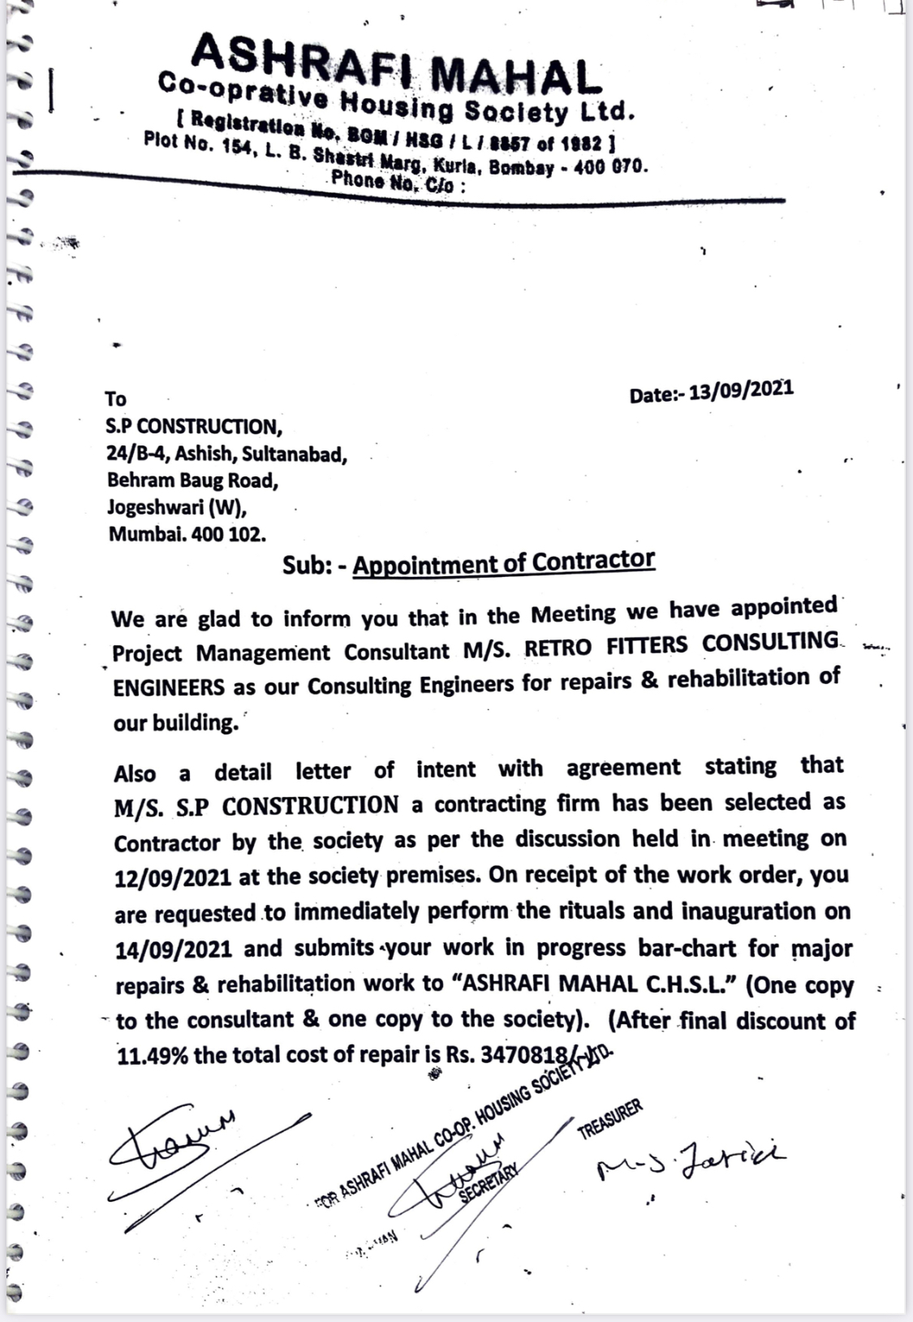

S.P. CONSTRUCTION

NAME OF SITE : Priyadarshan Society
ADDRESS : 380/381 Hussaini compound ,
N.D.& M.S.Road Bandra west
Mumbai -400050.

NO. OF BLDG : 1 BUILDING

NO. OF WING : 1 WING

FLOOR OF BLDG : GROUND + 3RD FLOOR

NO. OF FLATS : 24 Flats 2 Shop

PROJECT COST : 30,00,000 RUPEES

CONTRACT PERSON : MR. Afzal

CONTACT NO. : 9892018948
NATURE OF WORK : Structural repair ,ISMB Support
plaster and terrace shed

Work commencing From
15/11/2021

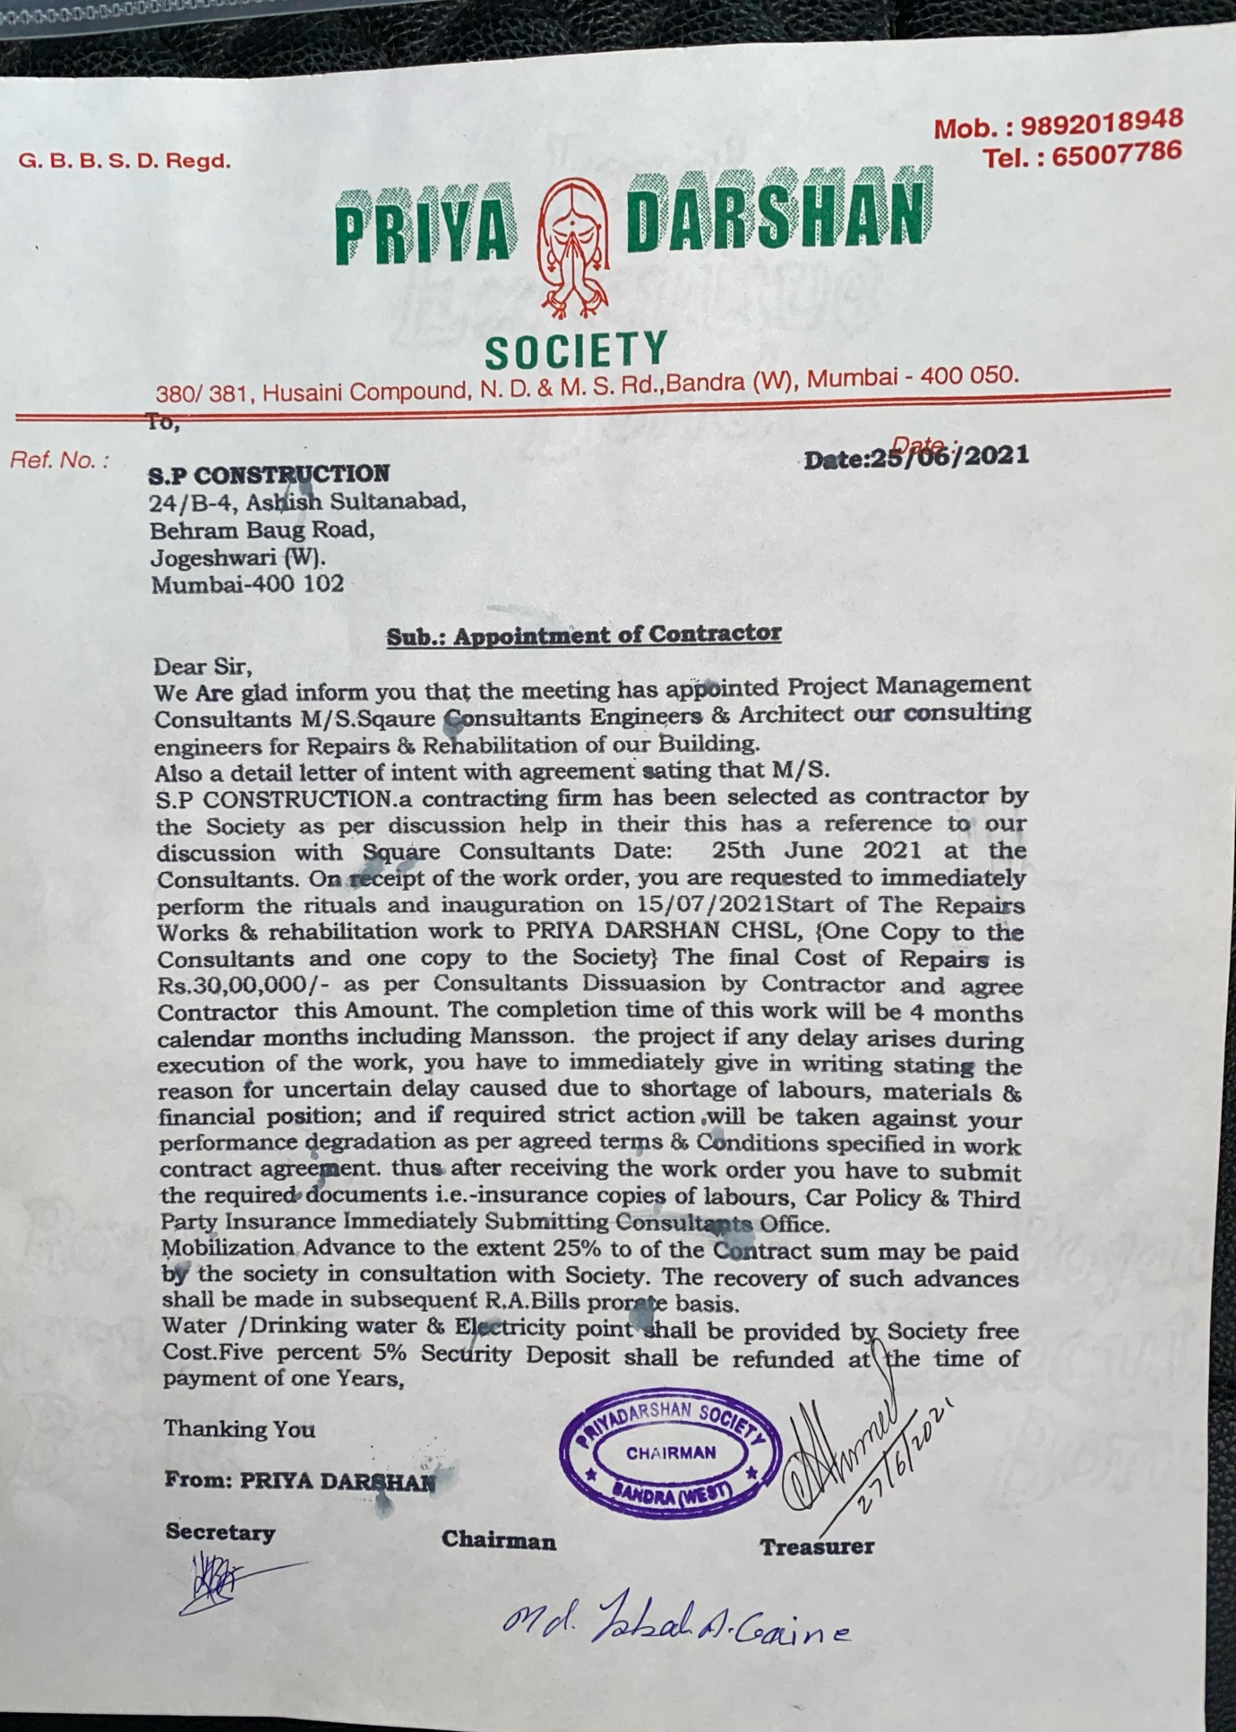

S.P. CONSTRUCTION

NAME OF SITE : Building no 310-312-314

ADDRESS : Kalbadevi road,Marine lines
Mumbai-400002

NO. OF BLDG : 1 BUILDING

NO. OF WING : 1 WING

FLOOR OF BLDG : GROUND + 4th FLOOR

NO. OF FLATS : 12

PROJECT COST : 36,00,000 RUPEES

CONTRACT PERSON : MR. VIJAY Torka

CONTACT NO. : 9820139461
NATURE OF WORK : Structural work/Polymer
treatment/plaster/ painting
Work is commencing from
11/07/2021

S.P. CONSTRUCTION

NAME OF SITE : Building no 321-325

ADDRESS : Kalbadevi road,Marine lines
Mumbai-400002

NO. OF BLDG : 1 BUILDING

NO. OF WING : 1 WING

FLOOR OF BLDG : GROUND +6th FLOOR

NO. OF FLATS : 49

PROJECT COST : 48,00,000 RUPEES

CONTRACT PERSON : MR. SN GHOSH

CONTACT NO. : 9820341960
NATURE OF WORK : Structural work
plaster/ painting
Work is commencing from
13/07/2021

S.P. CONSTRUCTION

NAME OF SITE : 74 BB

ADDRESS : OLD HANUMAN LANE 1 X LANE KALBADEVI ROAD MARINE LINES MUMBAI

NO. OF BLDG : 1 BUILDING

NO. OF WING : 1 WING

FLOOR OF BLDG : GROUND + 3RD FLOOR

NO. OF FLATS : 34 FLATS

PROJECT COST : 1,90,00,000 RUPEES (revised)

CONTRACT PERSON : MR. VIJAY GERUJA

CONTACT NO. : 9892286997
NATURE OF WORK : Pull Down work /New

Construction with IOD CC

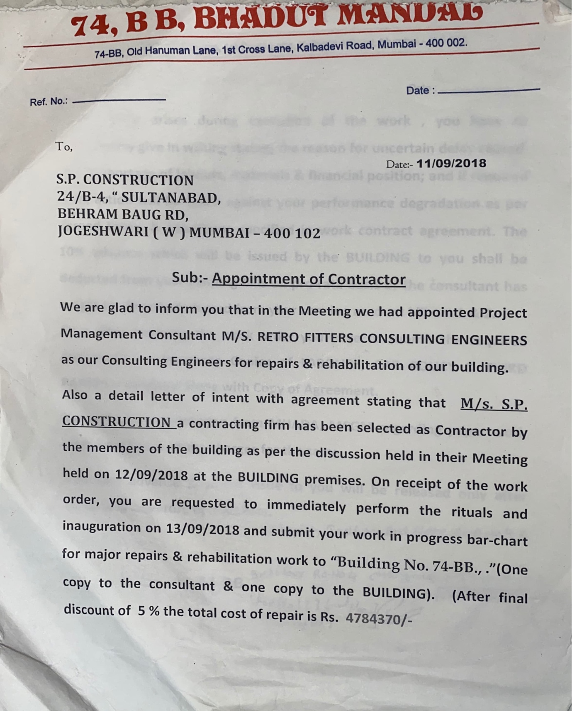

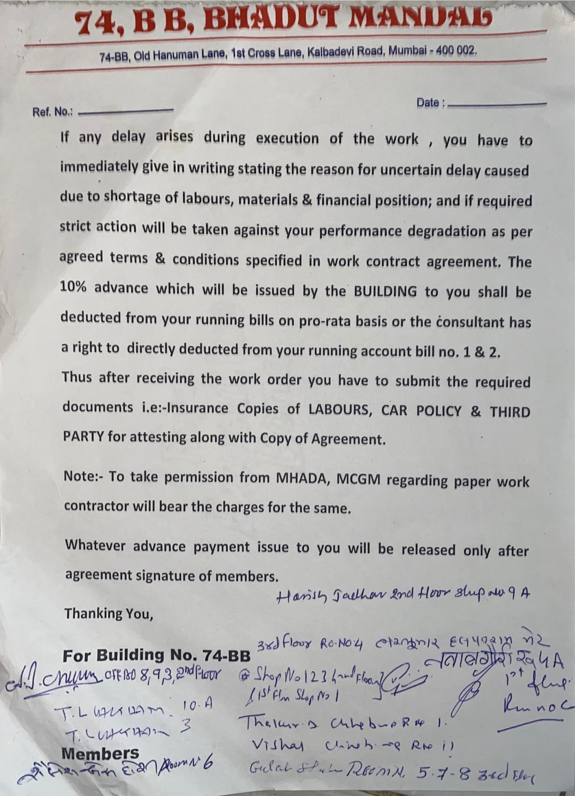

S.P. CONSTRUCTION

NAME OF SITE : Shreyas Building

ADDRESS : BLDG NO.82 ,Road no 25
Jain Society,Sion
NO. OF BLDG : 1 BUILDING

NO. OF WING : 1 WING

FLOOR OF BLDG : GROUND + 3rd FLOOR

NO. OF FLATS : 14FLATS

PROJECT COST : 29,60,785.00 Rupees

CONTRACT PERSON : MR. Vineet vora

CONTACT NO. : 9833280290

NATURE OF WORK : JACKETING, RECASTING
TERRACE WATERPROOFING POLYMER MODIFIED MORTAR Work

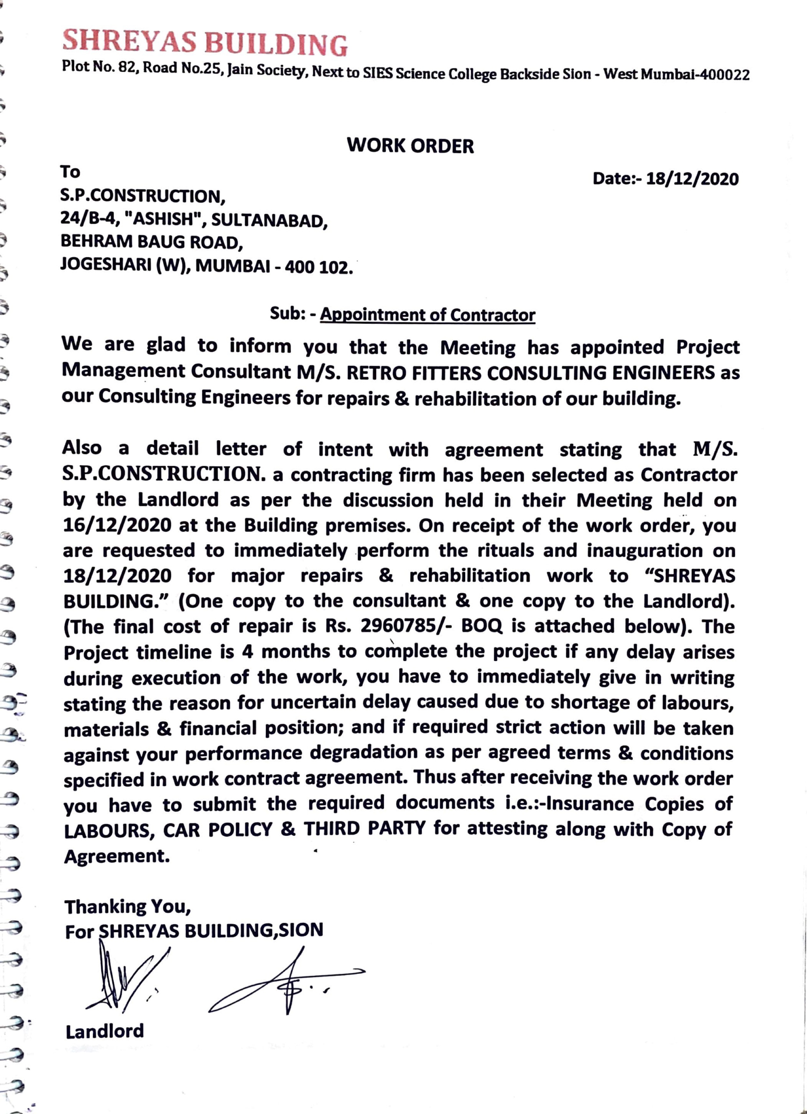

S.P. CONSTRUCTION

NAME OF SITE : SAI MANZIL

ADDRESS : BLDG NO.18, ALTA MOUNT ROAD, MALBAR HILL, MUMBAI 400007

NO. OF BLDG : 1 BUILDING

NO. OF WING : 1 WING

FLOOR OF BLDG : GROUND + 4TH FLOOR

NO. OF FLATS : 20 FLATS

PROJECT COST : 55,56,000.00 RUPEES

CONTRACT PERSON : MR. SHASHI

CONTACT NO. : 9821587879

NATURE OF WORK : JACKETING, GUNNINTING, POLYMER MODIFIED MORTAR WORK

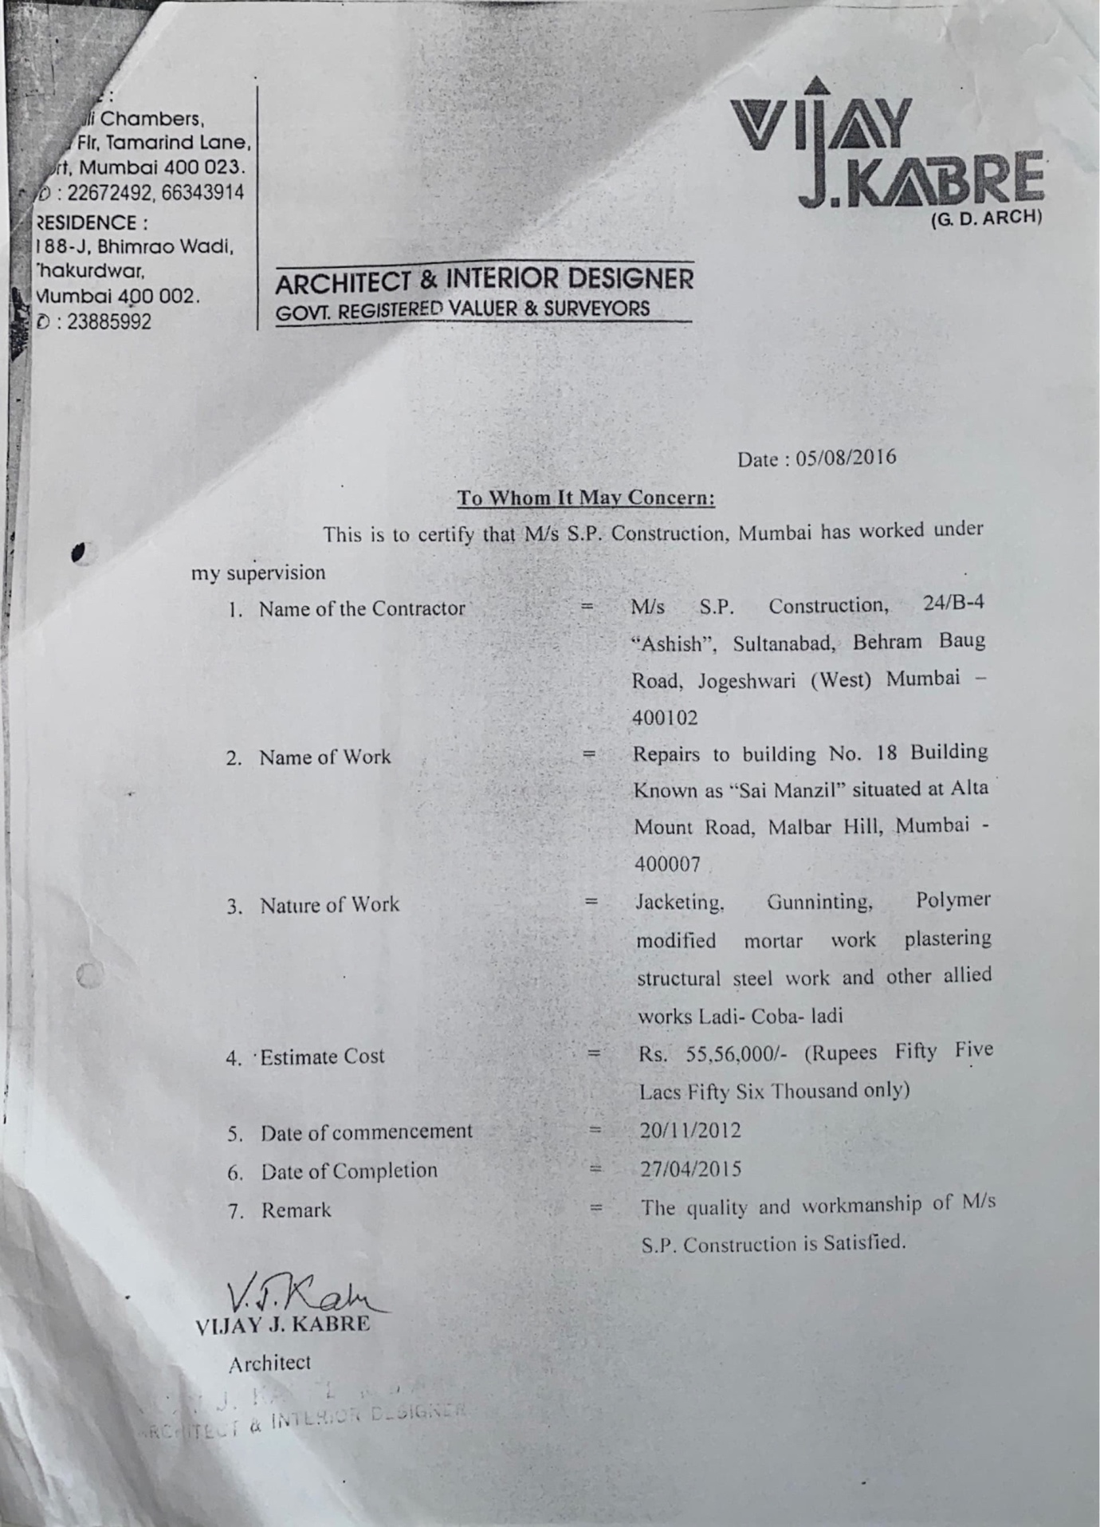
S.P. CONSTRUCTION

NAME OF SITE : LIVING-IN-STYLE SHOWROOM

ADDRESS : MOTILAL NEHRU NAGAR, OPP. BANGUR NAGAR POLICE STATION, GOREGAON (W), MUMBAI 400090

NO. OF BLDG : 1 BUILDING

NO. OF WING : 2 WING

FLOOR OF BLDG : GROUND + 3RD FLOOR

NO. OF FLATS :

PROJECT COST : 94,75,000.00 RUPEES

CONTRACT PERSON : MR. AFZAL CHANDIWALA

CONTACT NO. : 9820087572

NATURE OF WORK : CONSTRUCTION OF STRUCTURAL STEEL FRAME WORK

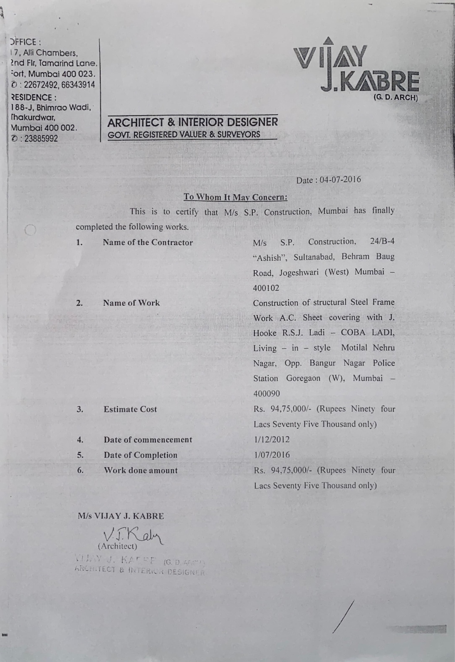
S.P. CONSTRUCTION

NAME OF SITE : LFS GROUP

ADDRESS : BUNGLOW NO.1 POST COMPOUND, HATKESH, OFF MIRA-BHAYANDER ROAD, KASHIMIRA, MIRAROAD (E), THANE

NO. OF BLDG : 1 BUILDING

NO. OF WING : 1 WING

FLOOR OF BLDG : GROUND + 3RD FLOOR

NO. OF FLATS : BUNGLOW

PROJECT COST : 62,50,000.00 RUPEES

CONTRACT PERSON : MR. ASHUTOSH KUMAR

CONTACT NO. :

NATURE OF WORK : ENTIRE CIVIL, INTERIOR & EXTERIOR WORK

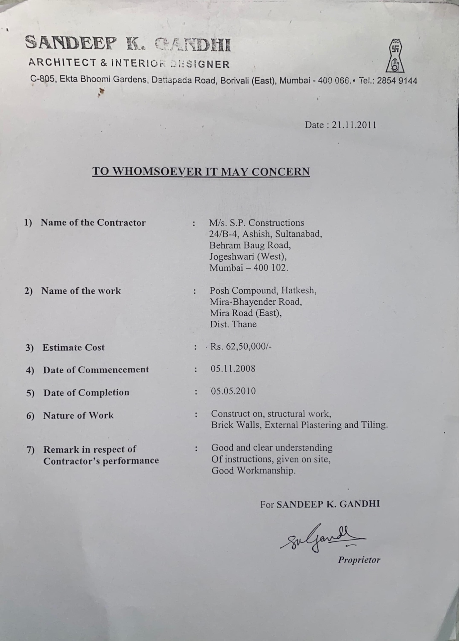

S.P. CONSTRUCTION

NAME OF SITE : BLDG NO. 52 / 54

ADDRESS : SLEATER ROAD, GRANTROAD (W), MUMBAI

NO. OF BLDG : 1 BUILDING

NO. OF WING : 1 WING

FLOOR OF BLDG : GROUND + 4TH FLOOR

NO. OF FLATS : 35 FLATS

PROJECT COST : 61,72,700.00 RUPEES

CONTRACT PERSON : MR. TINU

CONTACT NO. : 9820948923

NATURE OF WORK : STRUCTURAL WORK, BRICK WORK, INTERNAL & EXTERNAL PLASTERING & DRAINAGE WORK

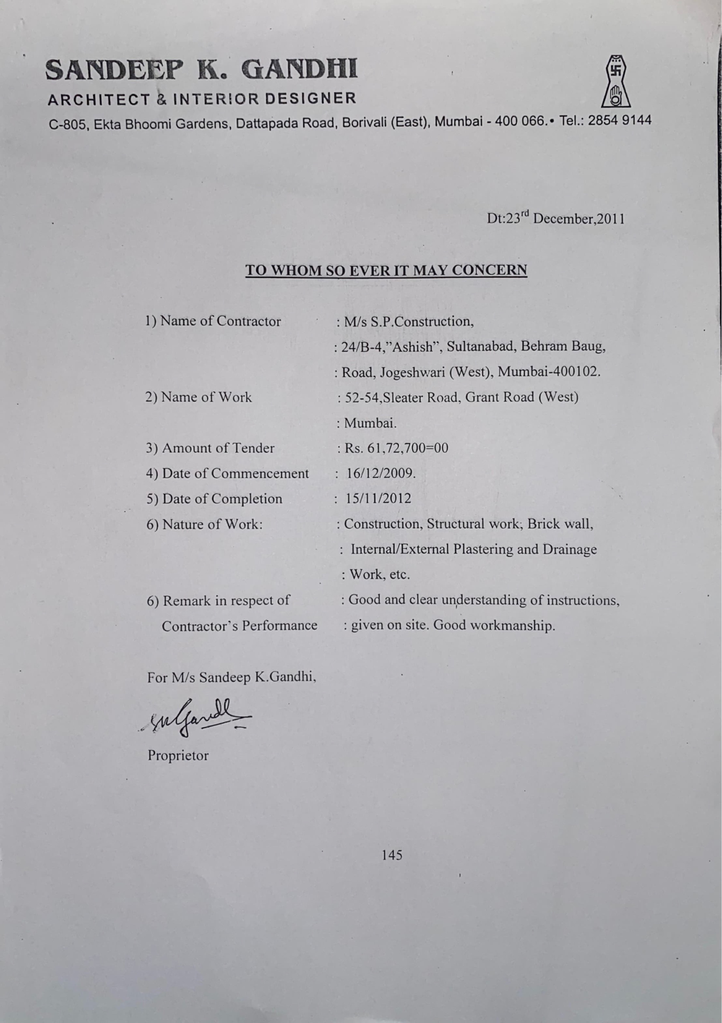

S.P. CONSTRUCTION

NAME OF SITE : SHYAM KAMAL D

ADDRESS : AGARWAL MARKET, OPP. VILE PARLE INTERNATIONAL HOTEL, VILE PARLE (E), MUMBAI 400057

NO. OF BLDG : 1 BUILDING

NO. OF WING : 2 WING

FLOOR OF BLDG : GROUND + 3RD FLOOR

NO. OF FLATS : 30 FLATS

PROJECT COST : 33,00,000.00 RUPEES

CONTRACT PERSON : MR. JITENDAR JAIN

CONTACT NO. : 9987066595

NATURE OF WORK : CHAJJA RECAST, PLASTERING,
MICRO CONCRET, PAINTING

S.P. CONSTRUCTION

NAME OF SITE : BUNGALOW NO. 92-93

ADDRESS : MAHADA COLONY, 4 BUNGALOW, ANDHERI WEST, MUMBAI 400053

NO. OF BLDG : 1 BUILDING

NO. OF WING : 1 WING

FLOOR OF BLDG : GROUND + 2ND FLOOR

NO. OF FLATS : BUNGALOW

PROJECT COST : 72,50,000.00 RUPEES

CONTRACT PERSON : MR. CHANDIWALA

CONTACT NO. : 9820087572

NATURE OF WORK : WATERPROOFING,
PLASTERING.
STRUCTURE REPAIR AND PAINTING

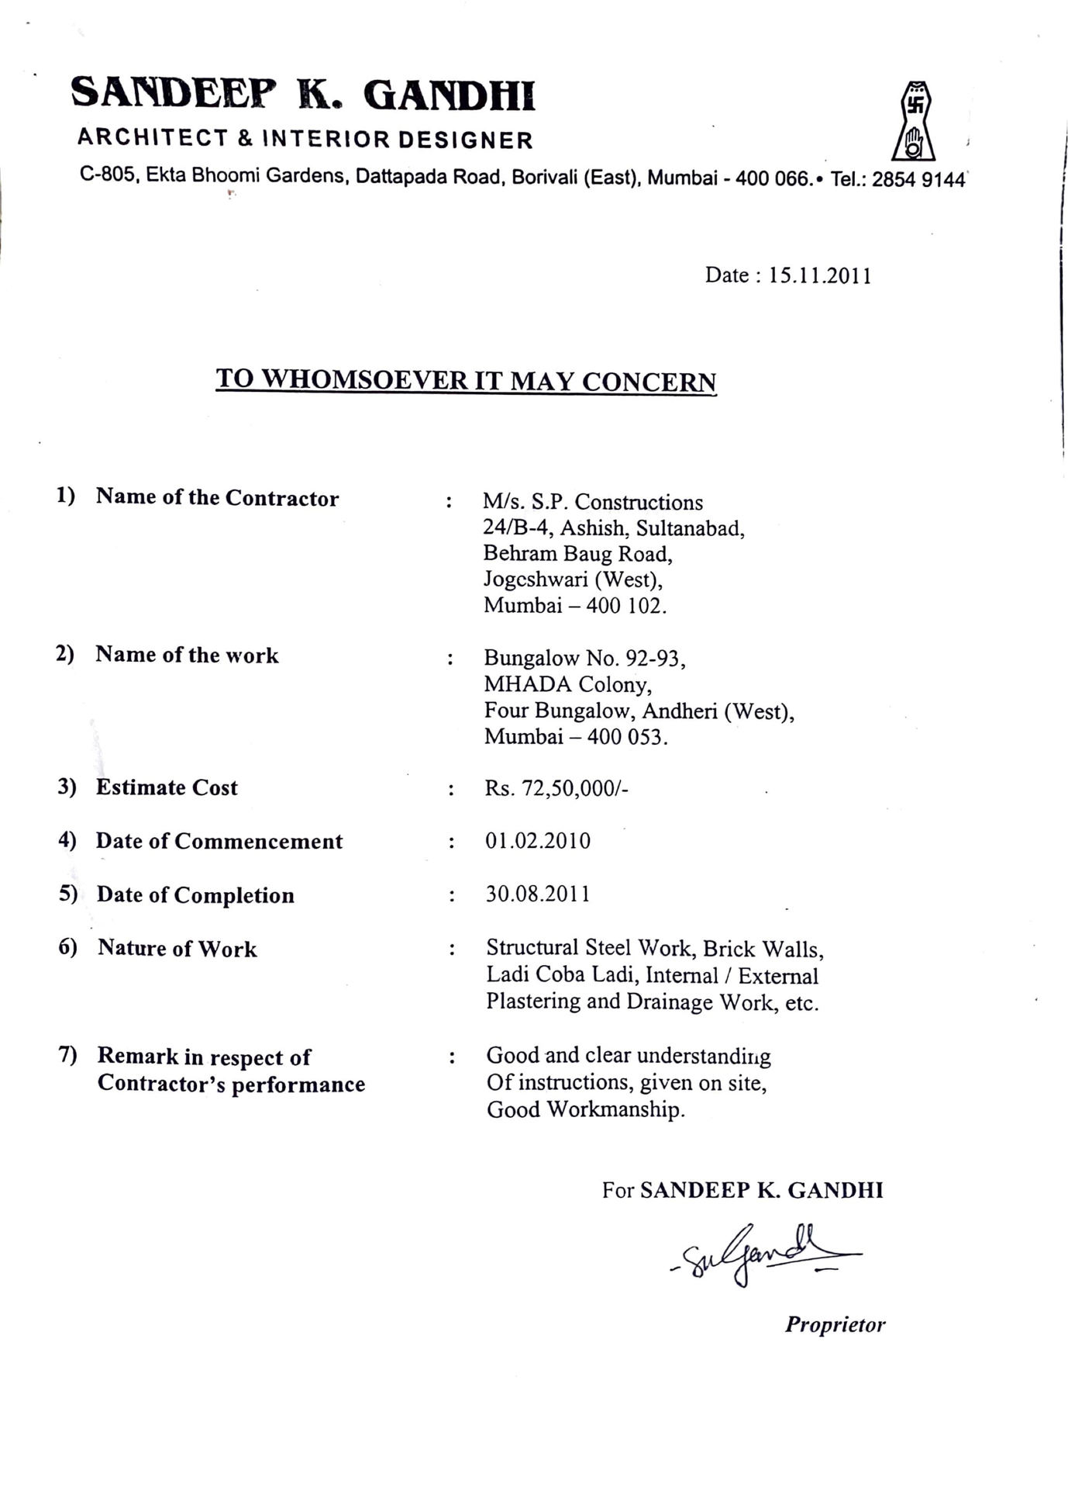

S.P. CONSTRUCTION

NAME OF SITE : BUILDING NO 94-100,

ADDRESS : PRINCESS STREET MARINE
LINES MUMBAI

NO. OF BLDG : 1 BUILDING

NO. OF WING : 1 WING

FLOOR OF BLDG : GROUND + 4TH FLOOR

NO. OF FLATS : 25 FLATS 8 SHOP

PROJECT COST : 62,00,000.00 RUPEES

CONTRACT PERSON : ----

CONTACT NO. : ----

NATURE OF WORK : TERRACE WATERPROFING,
PLASTERING.
STRUCTURE REPAIR AND PAINTING

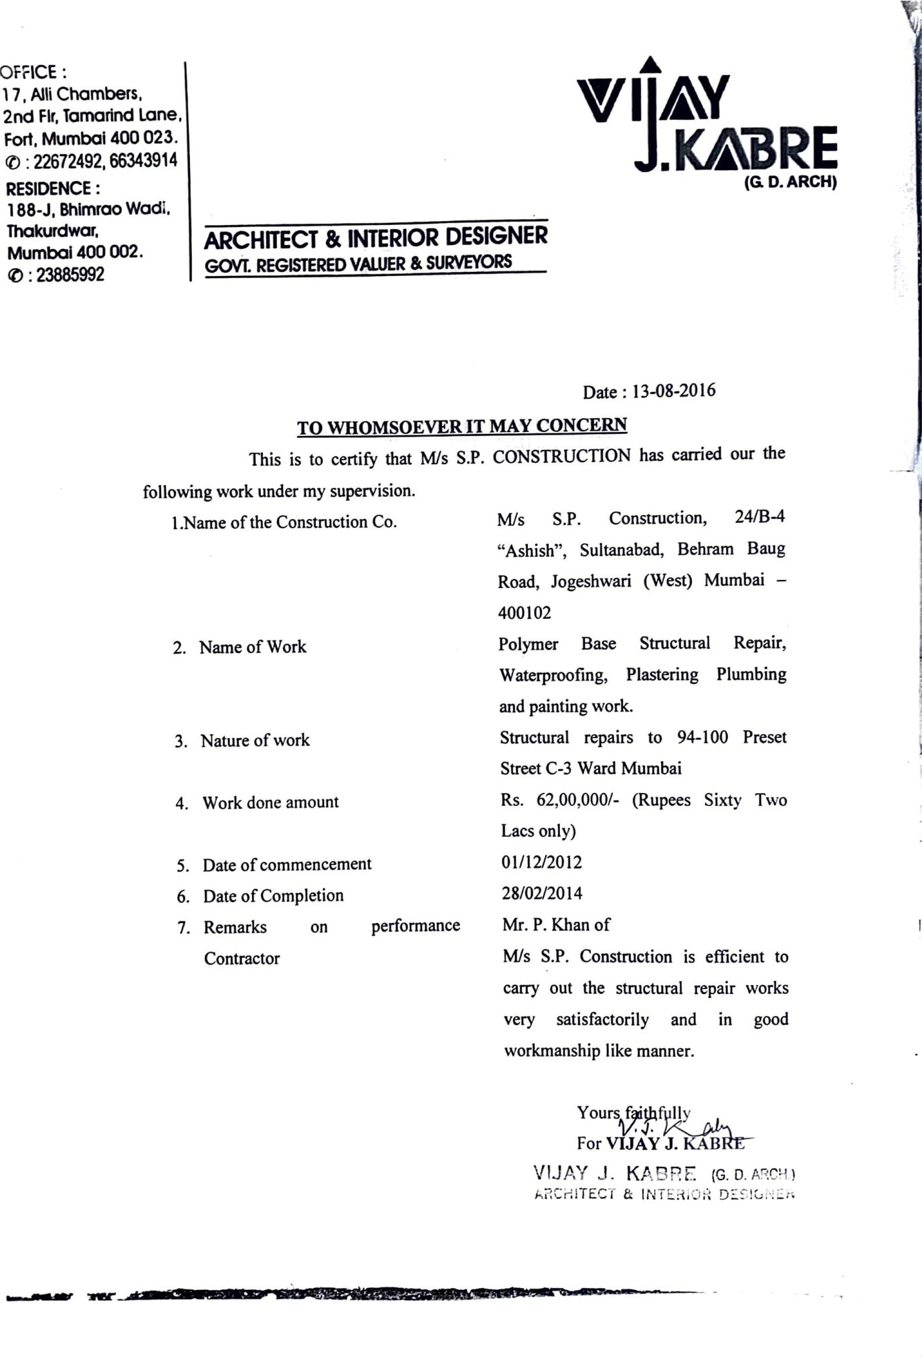
S.P. CONSTRUCTION

NAME OF SITE : LIVING-IN-STYLE

ADDRESS : BANGUR NAGAR,LINK ROAD
GOREGAON WEST , MUMBAI 400090

NO. OF BLDG : 1 BUILDING

NO. OF WING : 1 WING

FLOOR OF BLDG : GROUND + 3RD FLOOR

NO. OF FLATS : SHOWROOM

PROJECT COST : 33,75,000.00 RUPEES

CONTRACT PERSON : MR. CHANDIWALA

CONTACT NO. : 9820087572

NATURE OF WORK : CONSTRUCTION OF STEEL
STRUCTURAL STEEL ,REPAIR PAINTING

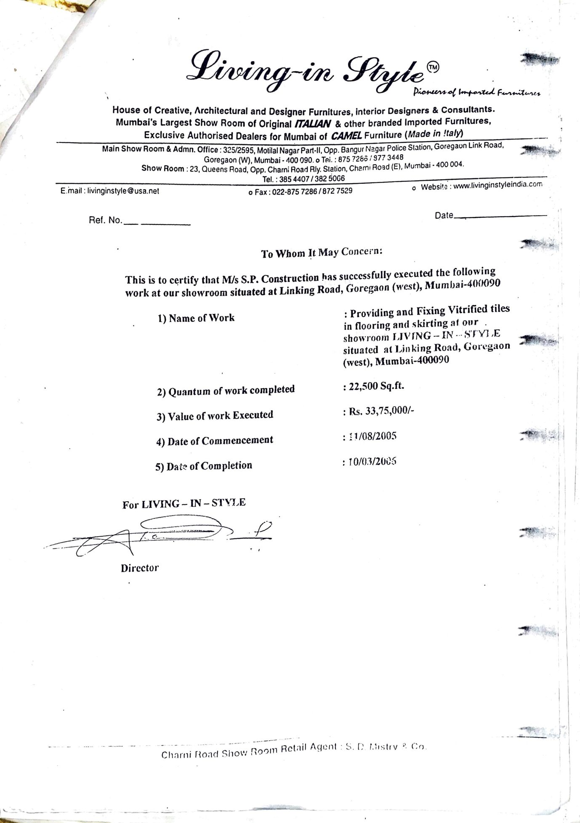

S.P. CONSTRUCTION

NAME OF SITE : BUILDING N0 19-20 KNOWN AS
MANGAL PREMISES CO-OP
SOC.LTD

ADDRESS : MAHAJAN GULLY ,ZAVERI
BAZAAR,MUMBAI 400002

NO. OF BLDG : 1 BUILDING

NO. OF WING : 1 WING

FLOOR OF BLDG : GROUND + 4TH FLOOR

NO. OF FLATS : 20

PROJECT COST : 55,00,000.00 RUPEES

CONTRACT PERSON : VIMAL BHAI

CONTACT NO. : 9869368566

NATURE OF WORK : CONSTRUCTION OF ROOMS IN
M.S.,COMMON PASSAGE AND
STAIRCASEBLOCK IN STEEL
FRAME WORK,CHANGING OF
MANGALORE TILES ROOF

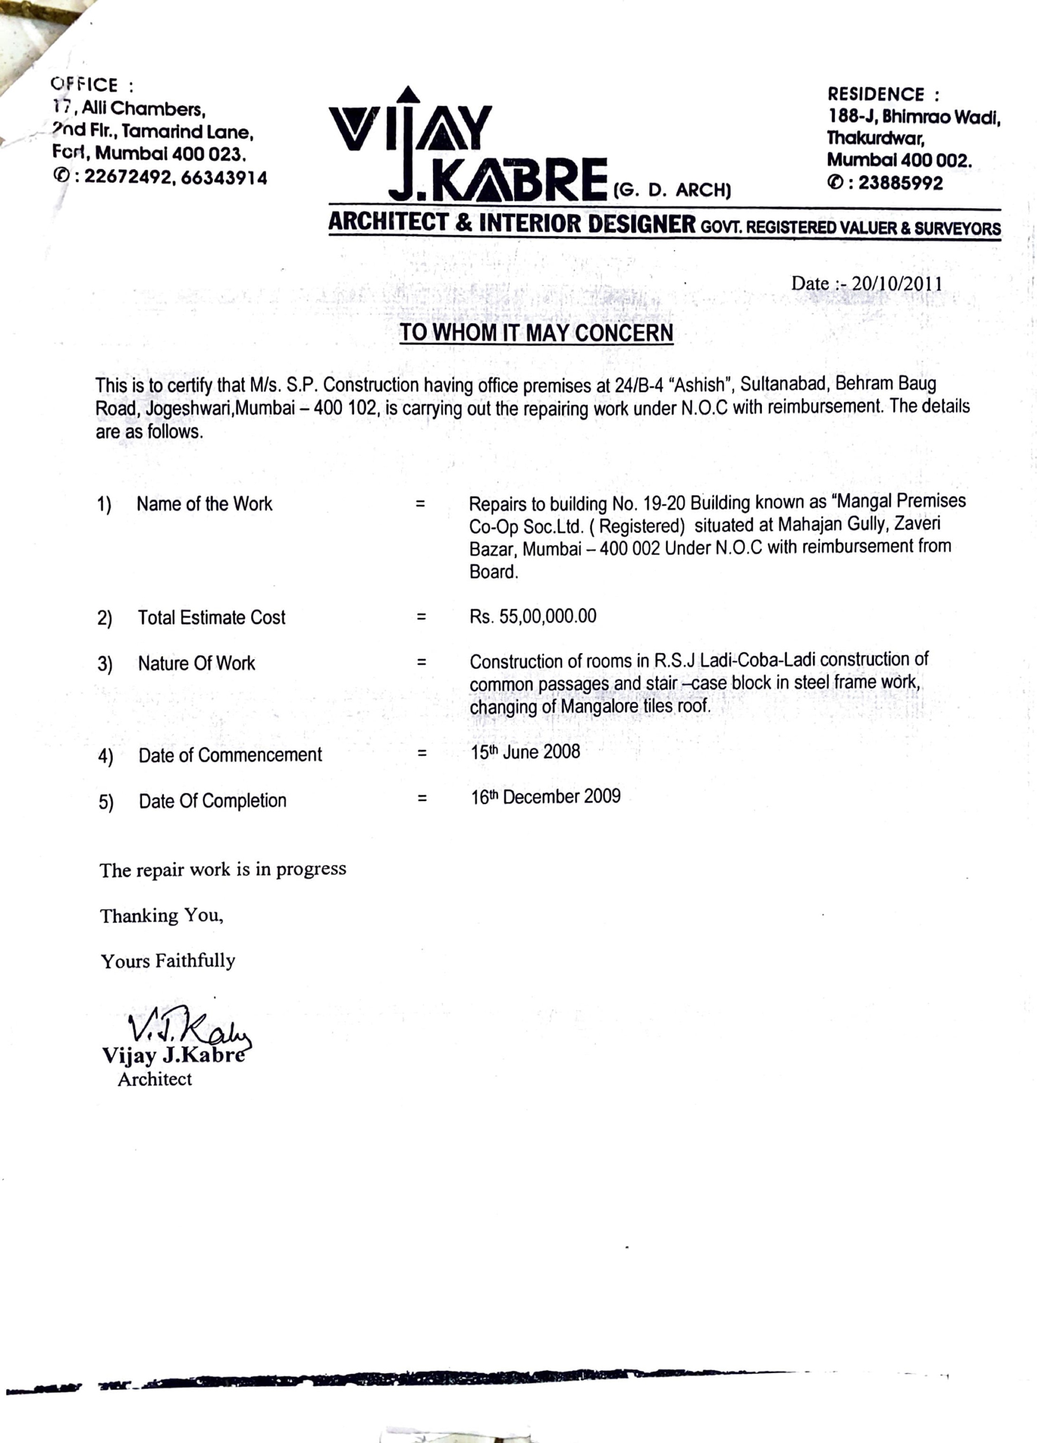

S.P. CONSTRUCTION

NAME OF SITE : BUNGLOW NO 92-93,

ADDRESS : MHADA COLONY,4
BUNGLOW,ANDHERI
WEST,MUMBAI 400053

NO. OF BLDG : BUNGLOW

NO. OF WING : 1 WING

FLOOR OF BLDG : GROUND + 2ND FLOOR

NO. OF FLATS : BUNGLOW

PROJECT COST : 72,50,000.00 RUPEES

CONTRACT PERSON : ----

CONTACT NO. : ----

NATURE OF WORK : STRUCTURAL STEEL
WORK,BRICK WALL,INTERNAL
EXTERNAL PLASTER
& DRAINAGE WORK ETC

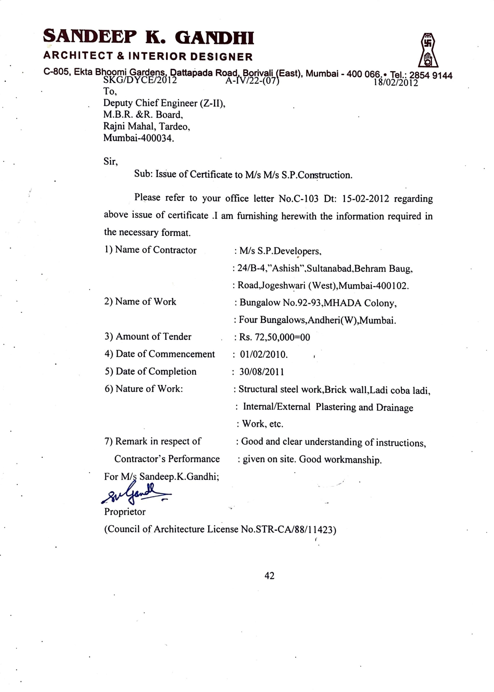

S.P. CONSTRUCTION

NAME OF SITE : VAIKUNTH APPARTMENT,

ADDRESS : WARDEN ROAD,NEAR BREACH
CANDY MUMBAI

NO. OF BLDG : BUILDING

NO. OF WING : 1 WING

FLOOR OF BLDG : GROUND + 4TH FLOOR

NO. OF FLATS : 16

PROJECT COST : 42,00,000.00 RUPEES

CONTRACT PERSON : ----

CONTACT NO. : ----

NATURE OF WORK : POLYMER BASE STRUCTURAL
REPAIR,WATERPROFFING,
PLASTERING,PLUMBING &
PAINTING WORK

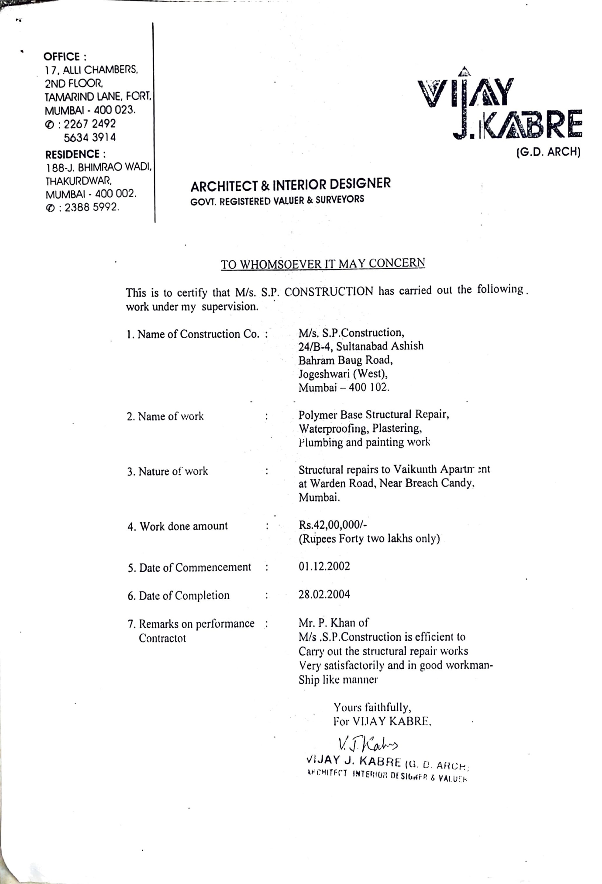

S.P. CONSTRUCTION

NAME OF SITE : NOOR MASJID,

ADDRESS : OPP.BANGUR NAGAR POLICE
STATION,GOREGAON (W)
MUMBAI 400090

NO. OF BLDG : 1

NO. OF WING : 1 WING

FLOOR OF BLDG : GROUND +3RD FLOOR

NO. OF FLATS : ---

PROJECT COST : 94,75,000.00 RUPEES

CONTRACT PERSON : Afzal sir

CONTACT NO. : 022 3854407

NATURE OF WORK : STRUCTURAL STEEL FRAME
WORK,BRICK WALL,INTERNAL
EXTERNAL PLASTER

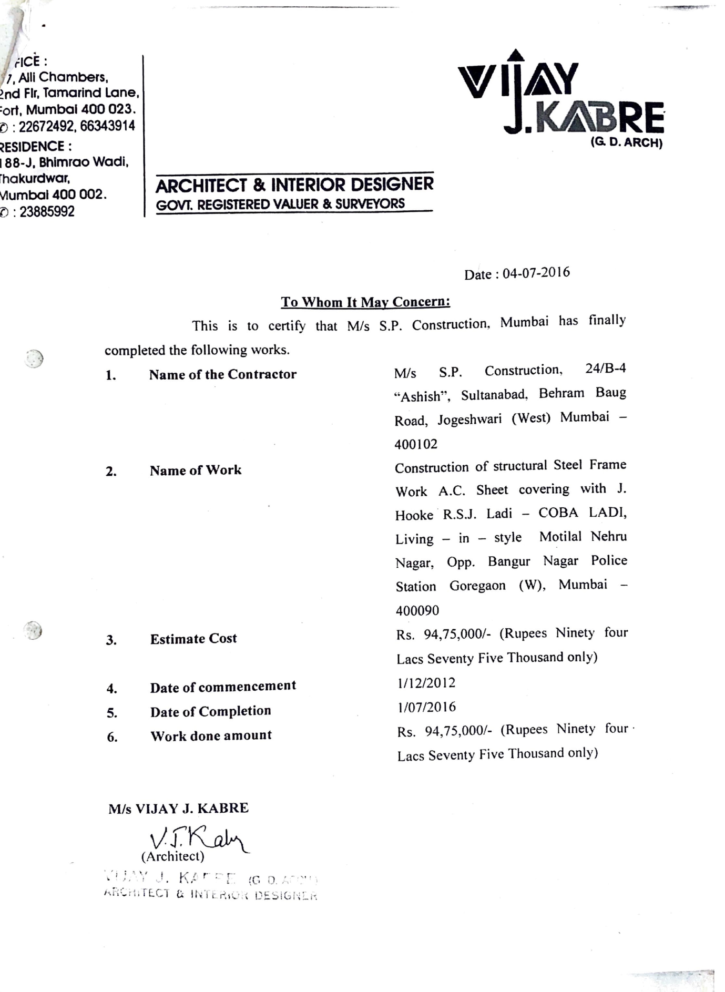

S.P. CONSTRUCTION

NAME OF SITE : 20-48 , K.M.Sharma Marg

ADDRESS : LOHAR CHAWL , MUMBAI

400002

NO. OF BLDG : BUILDING

NO. OF WING : 1 WING

FLOOR OF BLDG : GROUND + 4TH FLOOR

NO. OF FLATS : 16

PROJECT COST : 42,00,000.00 RUPEES

CONTRACT PERSON : ----

CONTACT NO. : ----

NATURE OF WORK : STRUCTURAL REPAIR

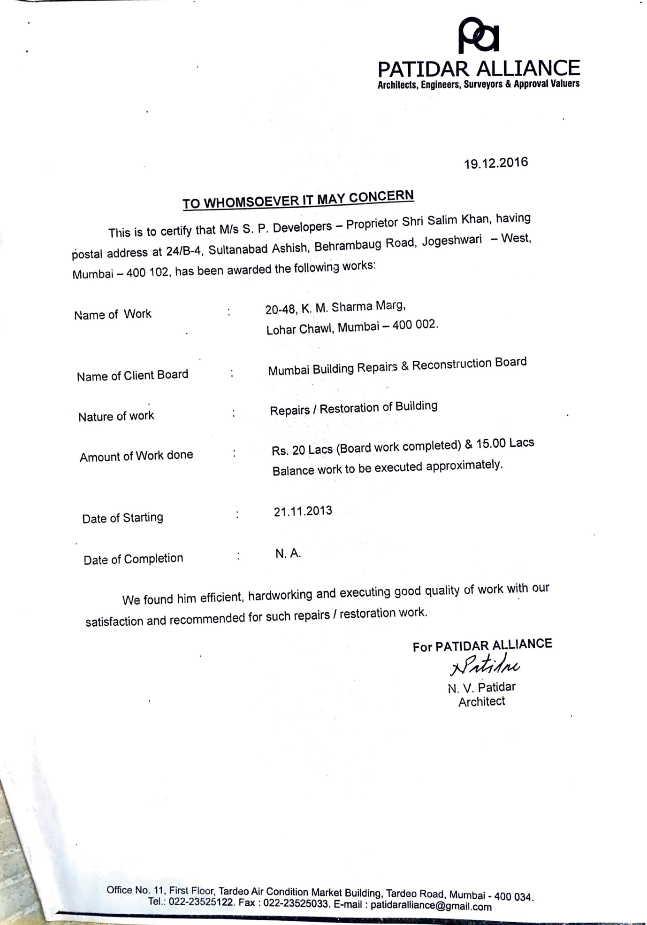


OUR BANKERS

S P CONSTRUCTION

AC NO : 32260200000127

IFSC CODE : BARB0JOGWES

ADD: BLOSSOM PARK SHOP NO. 4 NEAR FAROOQ HIGH SCHOOL,S V ROAD JOGESHWARI WEST MUMBAI400102

GST REGISTRATION
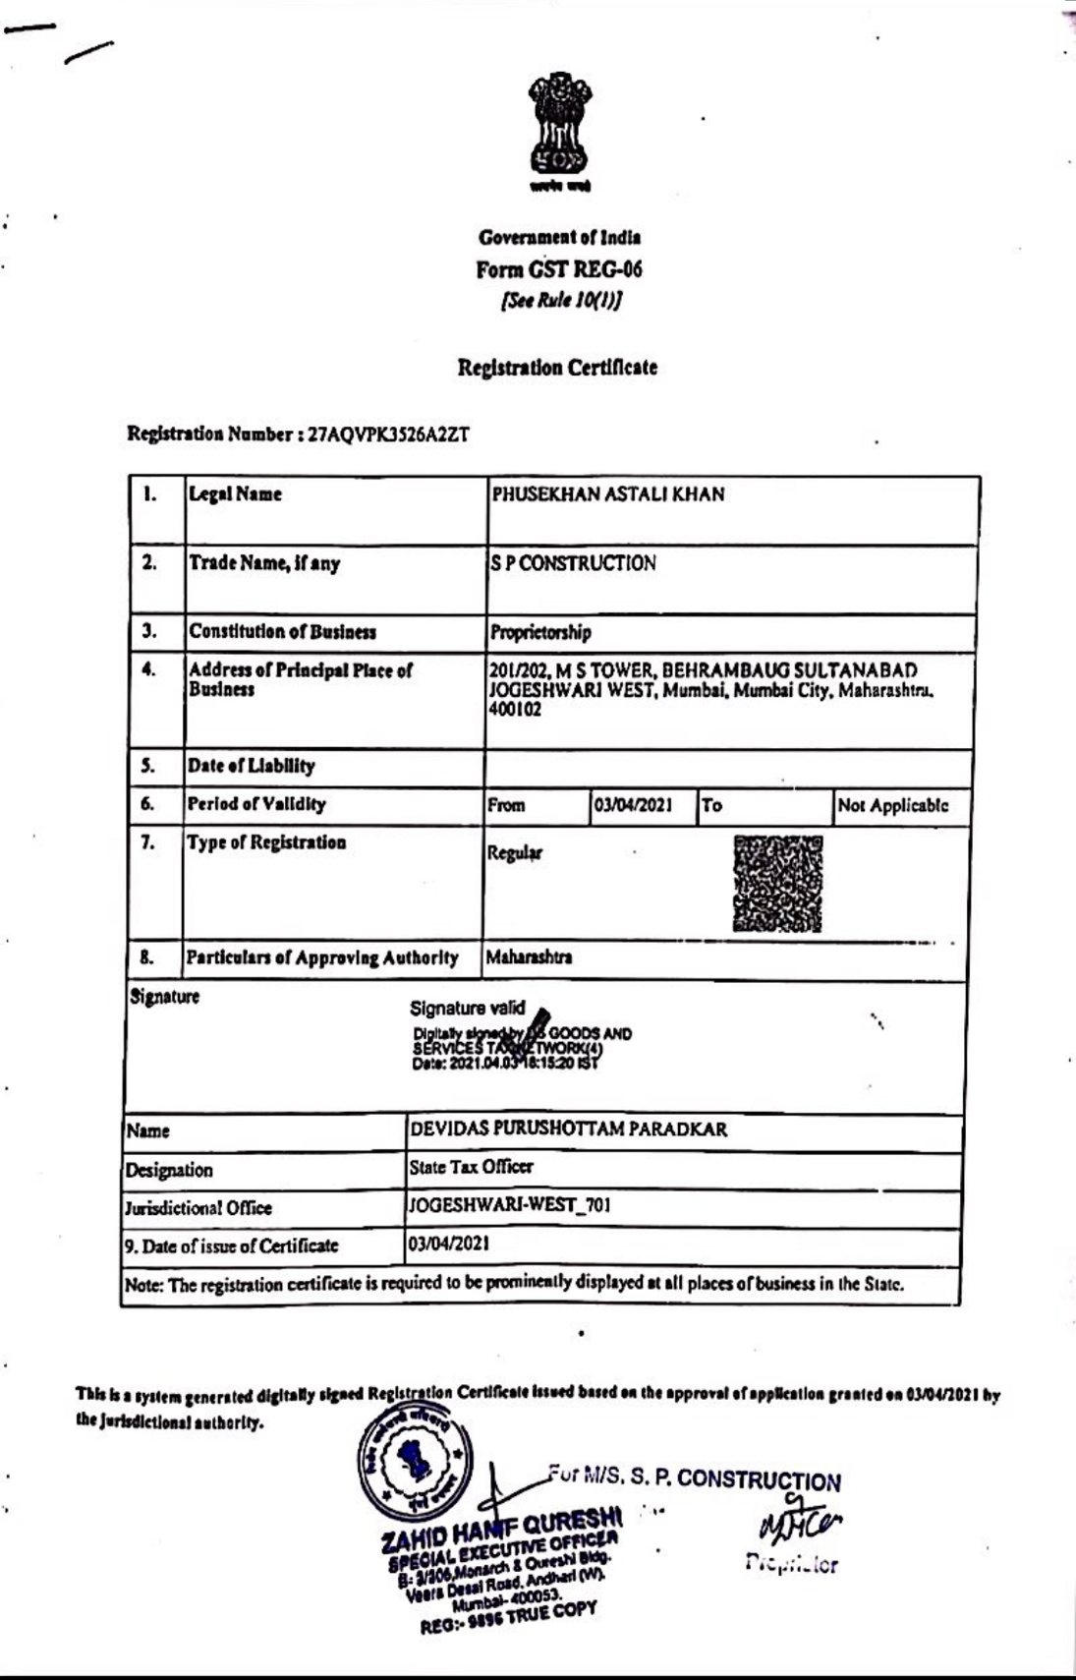

PICTURE OF VARIOUS WORKS

COLUMN JACKETING
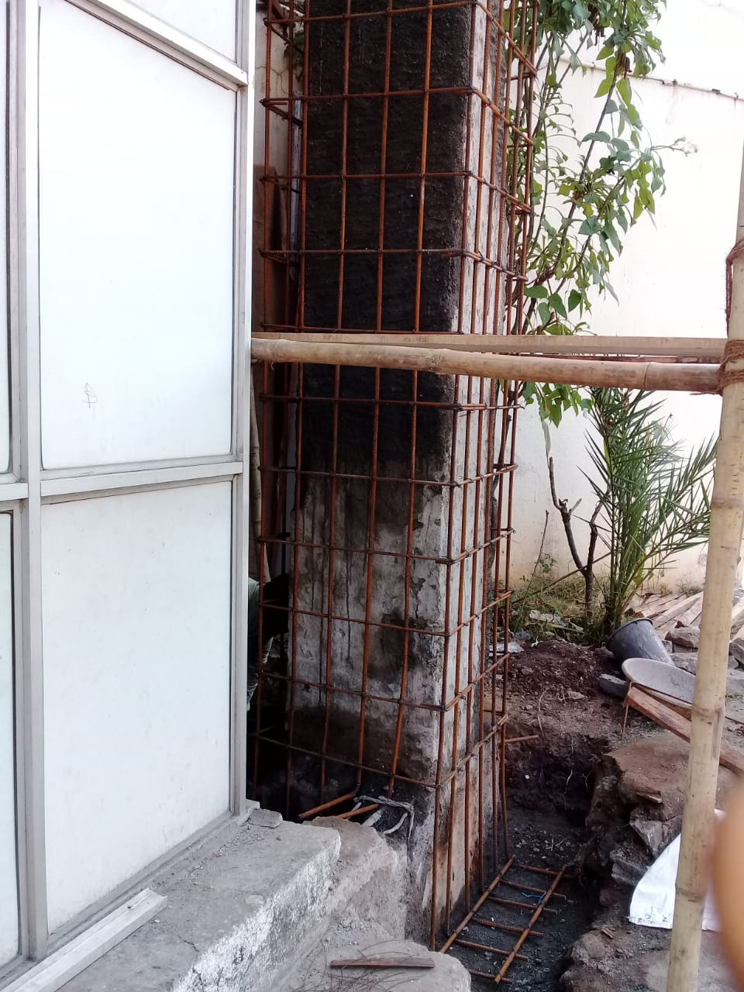
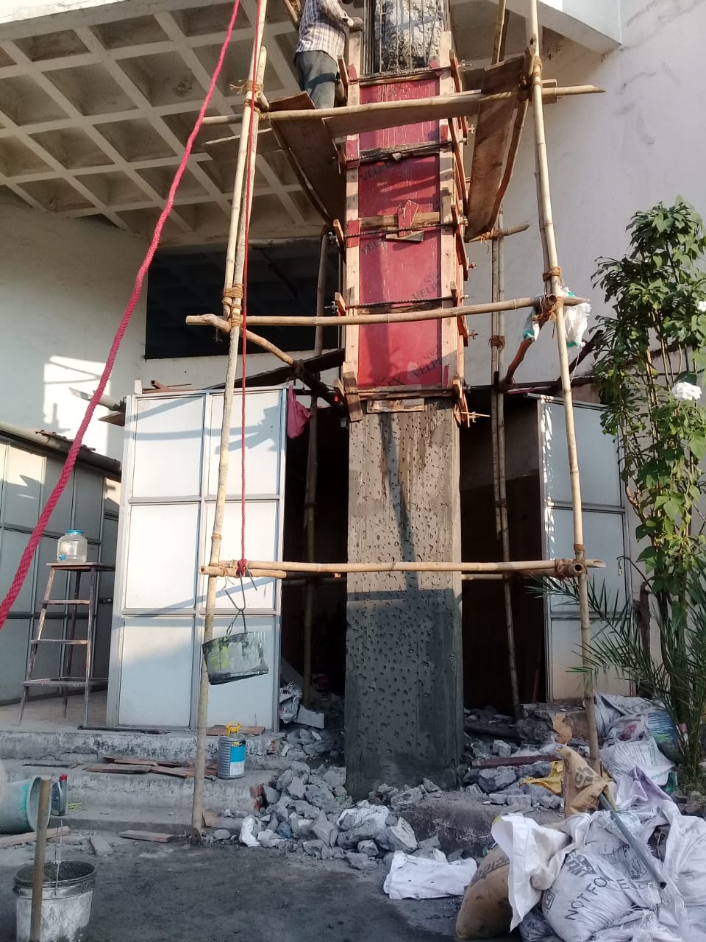

DR. FIXIT COATING

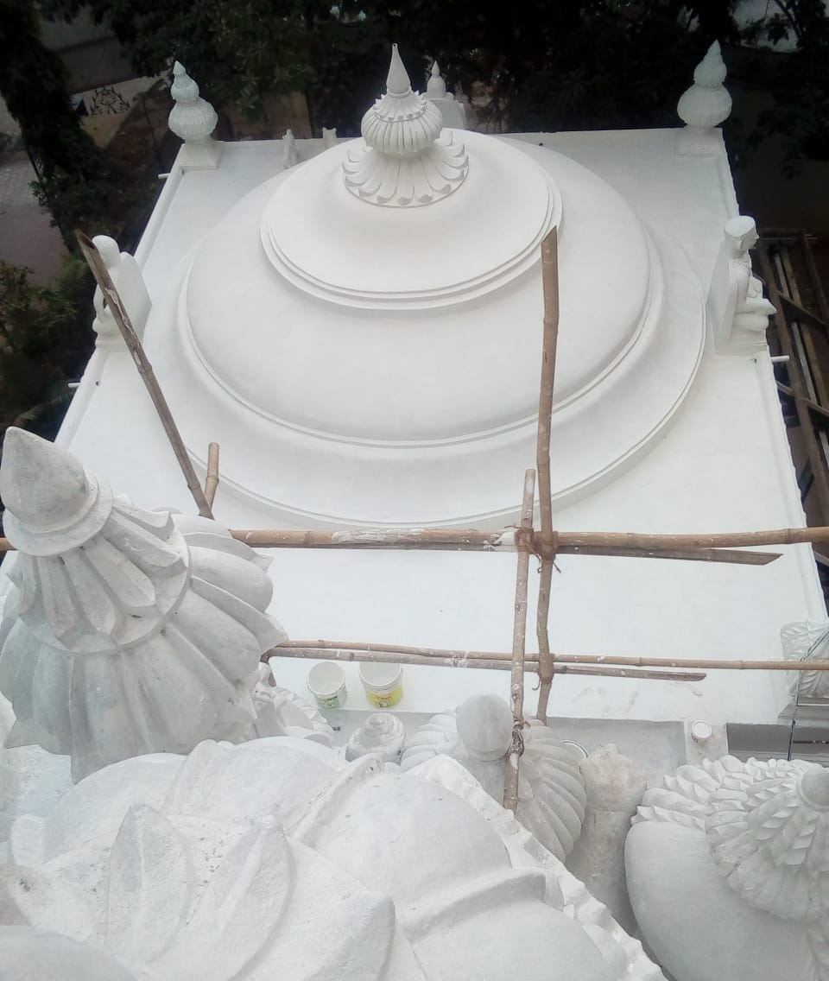

BRICKBAT KHOBA
WATERPROOFING

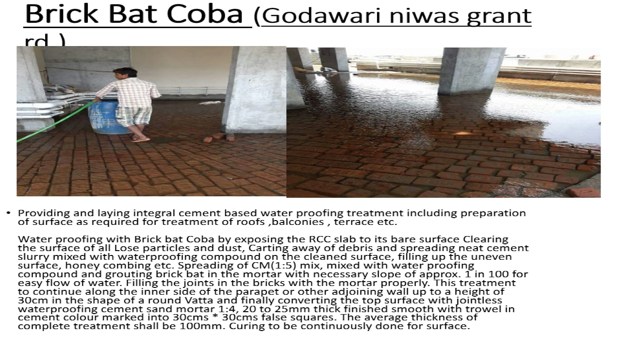
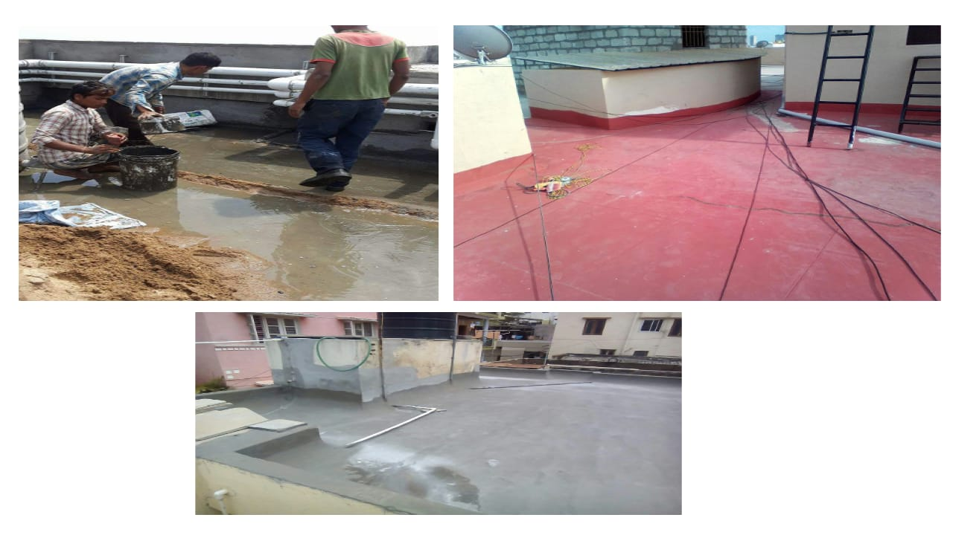

STRUCTURAL REPAIR

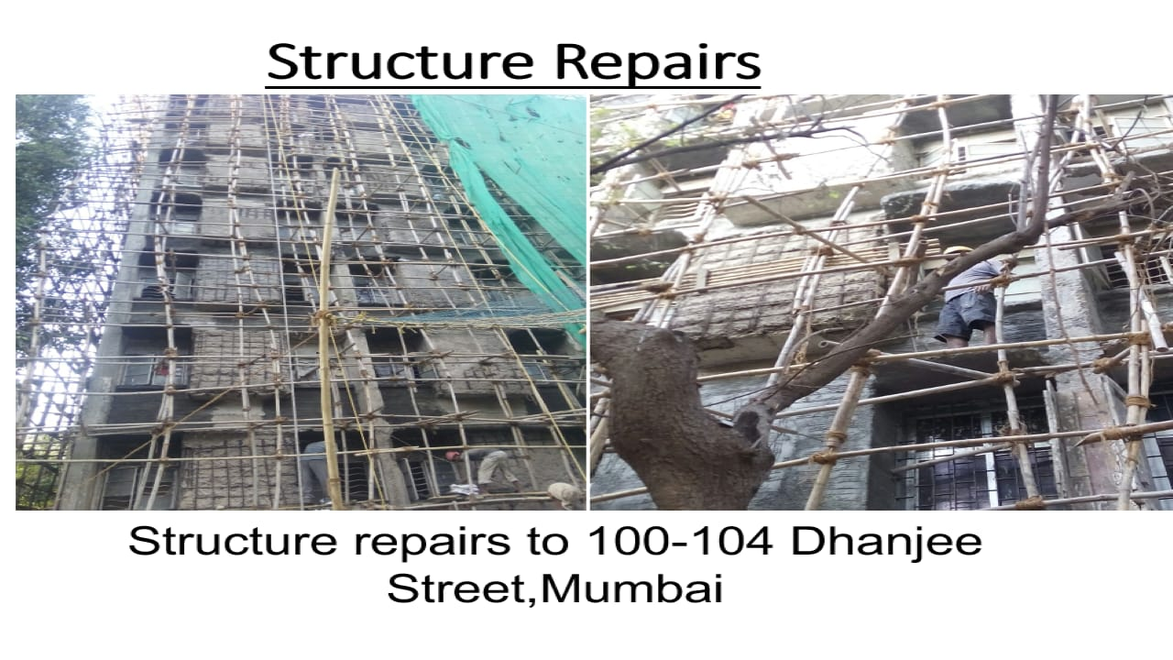

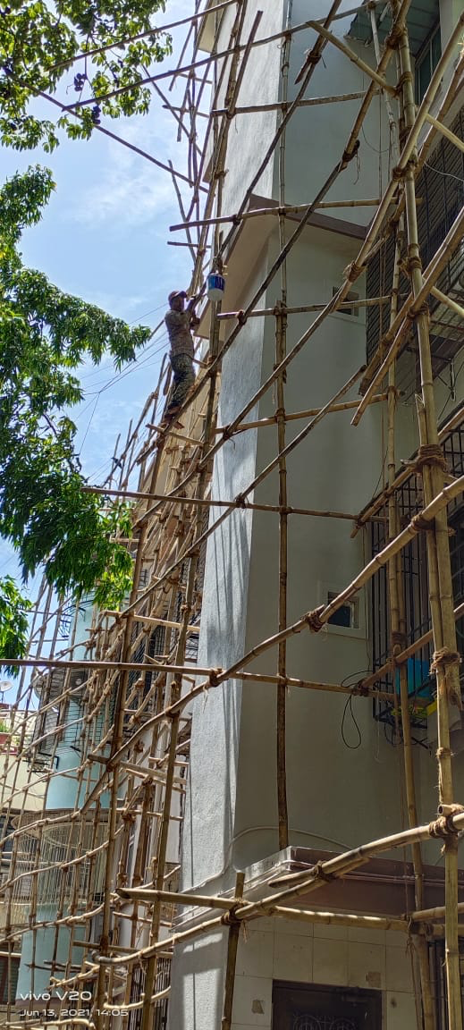
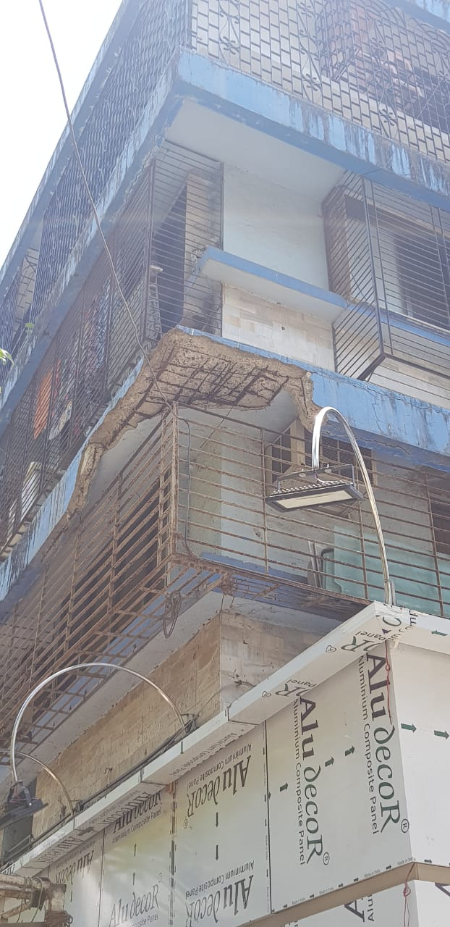
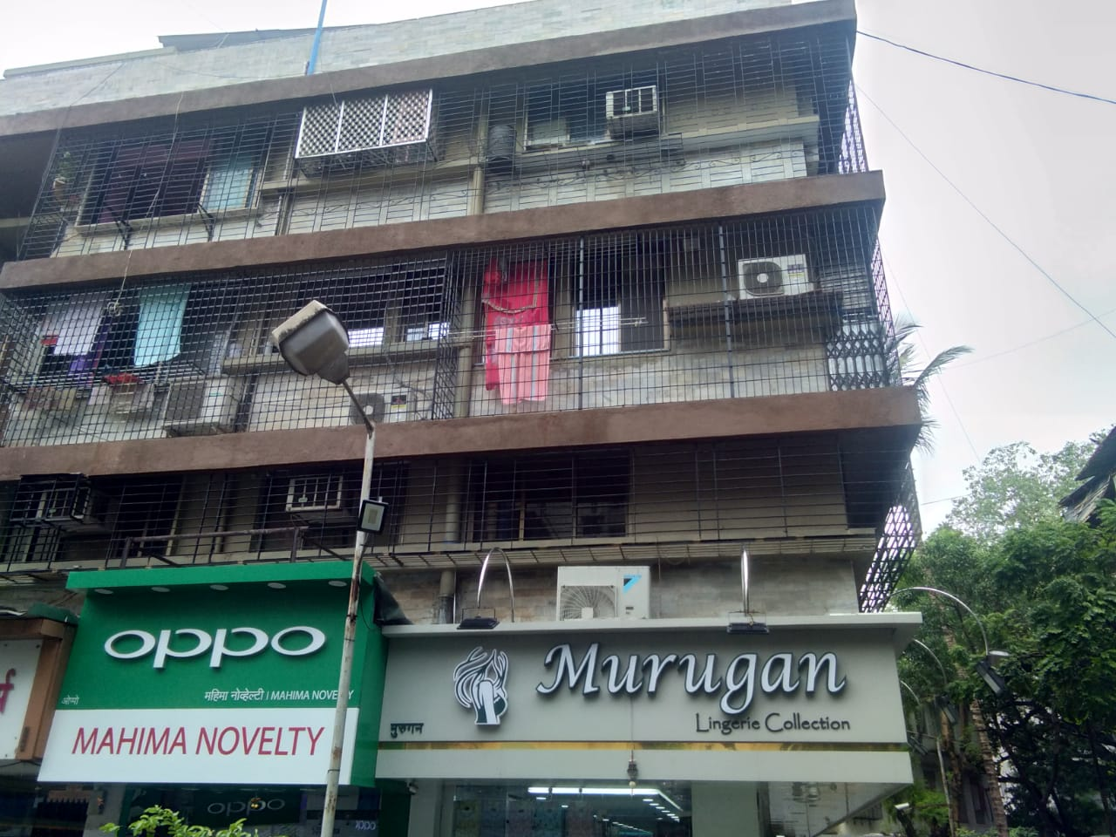

THANK YOU FOR YOUR TIME

- For any clarification and inquiry, kindly contact

Mr. Phuse Khan : +91 9820216437 (Proprietor)
Email Id : spconst44@gmail.com

Mr. Ayyub Khan : +91 9619057606
Email Id : ayyub44@gmail.com

